PowerTeacher -
WCPSS Supplemental
Training Document

June 2013

Student Information Systems
Wake County Public School System

Please refer to the following videos for additional support:
http://edmodo.com/folder/1337870

Introduction

During the PowerTeacher Gradebook training, Pearson will provide the teacher with an overall generic functionality of the Gradebook application for PowerSchool in a training environment. Due to this generality, it was decided that some district specific standards should be established for elementary school teachers receiving the Pearson training, based upon collaboration between Pearson, WCPSS Academics, and WCPSS Student Information Systems.

PowerTeacher Gradebook Standards for WCPSS

WCPSS Academics has determined that elementary school teachers should use the following standards when managing their Gradebooks in PowerTeacher:
- All teachers must use Gradebook to record students’ assignments, grades, and daily attendance using the WCPSS standards-based grading rubric.
- Assignments entered in the Gradebook should be created to assess a student’s level of understanding according to the expectations of the standard (this should not include formative assessments or benchmark tests).
- Each assignment should be weighted one time (1.0).
- Each assignment created should have at least one corresponding standard attached, and the grades should be the same in both columns for the assignment and the standard.
- Each standard assessed during a specific quarter should have a minimum of 3 assignments (For ELA, this only applies to the focus standards in bold).
- Work Habits should be assessed/graded in the teacher’s “Homeroom” class.

Elementary school principals should consider the following questions when establishing building level expectations for consistency in Gradebook in preparation for the upcoming parent portal:
- Should deadlines be established for teachers entering assignments into the Gradebook (i.e., weekly, biweekly)?
- Should PLTs work to create common assignments that will be entered into the Gradebook?
- Who needs access to building level data in your school (i.e., Special Education teachers, IRT, etc.)?
- What on-site professional development and/or conversations need to take place to better align grading practices to standards-based grading?
- What structure will be used and how often will work habits/conduct assignments be entered and graded in the Gradebook to align with the 1-3 rubric?
- How will the school ensure the work samples and behavior reports sent home align to the scores recorded in Gradebook?

This documentation was created using a Pearson training website, so the data provided in the screenshots may not be applicable to WCPSS. This documentation has been created for the purposes of functionality and WCPSS Academic standardization for elementary schools and not specific to the data provided in the following screenshots.
Each assignment created should have at least one corresponding standard attached, and the grades should be the same in both columns for the assignment and the standard.

To add an assignment for a class, click to highlight the specific class under Classes, and then click on the Assignments tab. Click the + sign to enter the assignment information.

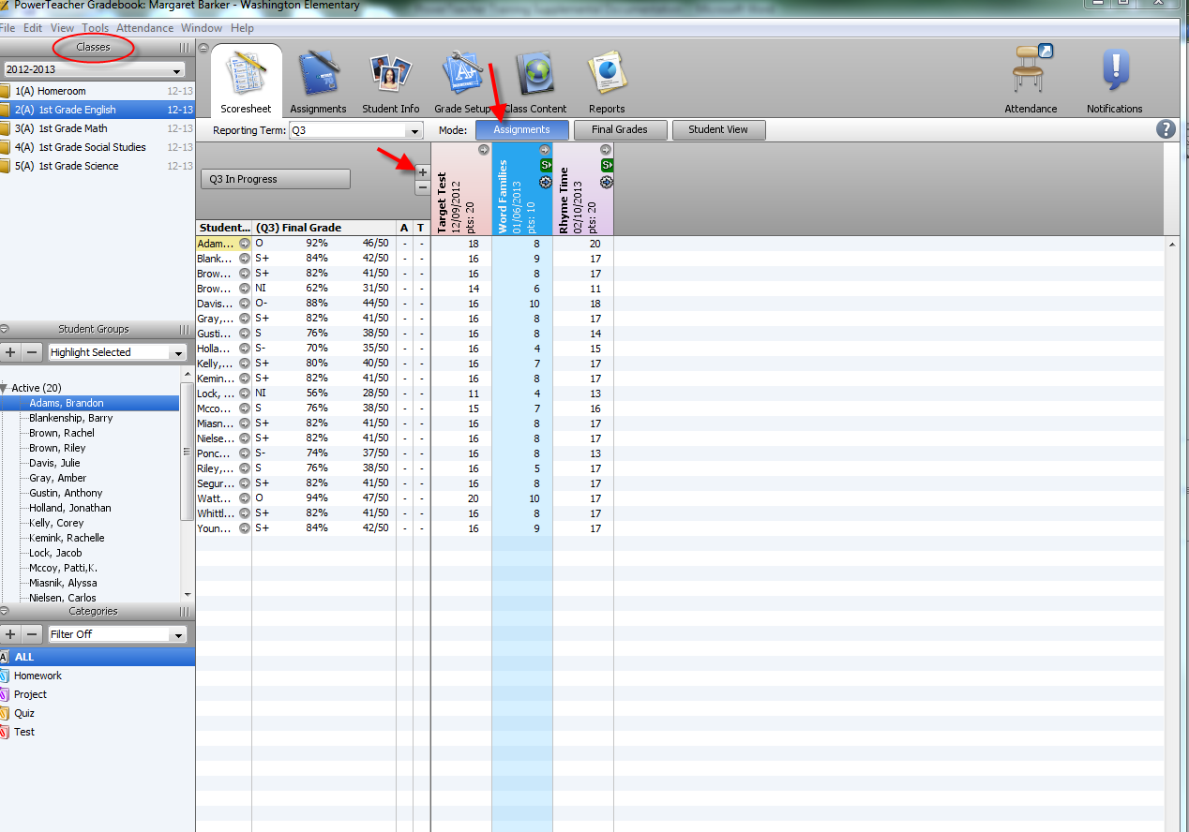

The New Assignment screen will be displayed. Enter information about the assignment and click to Save.

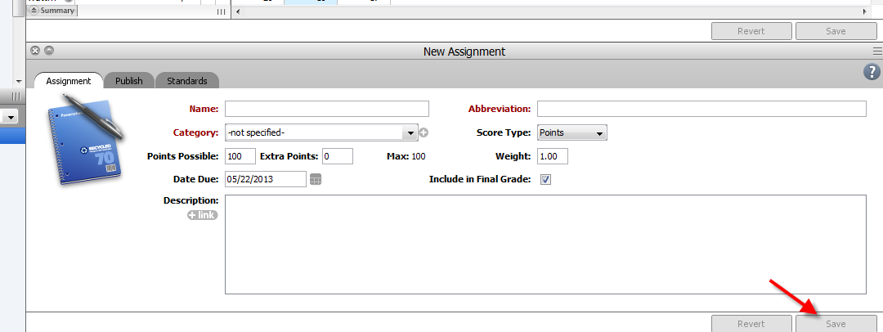

When creating an assignment for a class, also include at least one standard. Click on the Standards tab to select one or more standards to be attached to the assignment. Standards will be provided in a list to choose which is assessed with the specific assignment.

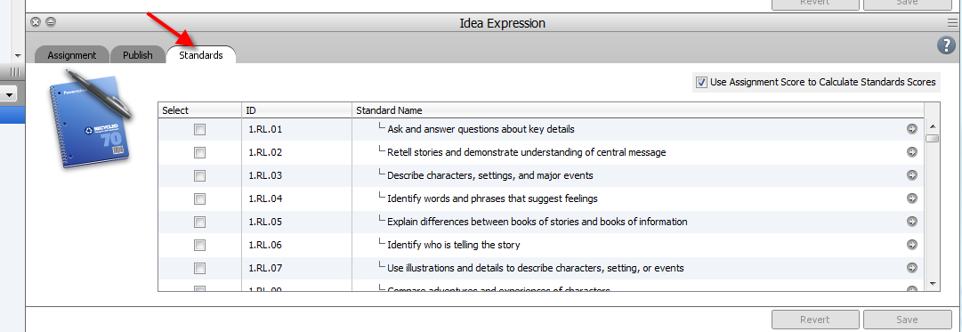

Select the appropriate standard(s) by checking the box in the Select column beside the standard(s). Then, click to Save.

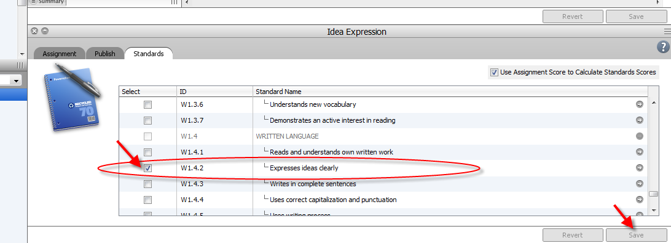

If an assignment has been previously created, but a standard was not attached, click on the Assignment tab to see the assignment created.

Click on the Standards tab, to continue the process to attach one or more standards to the assignment.

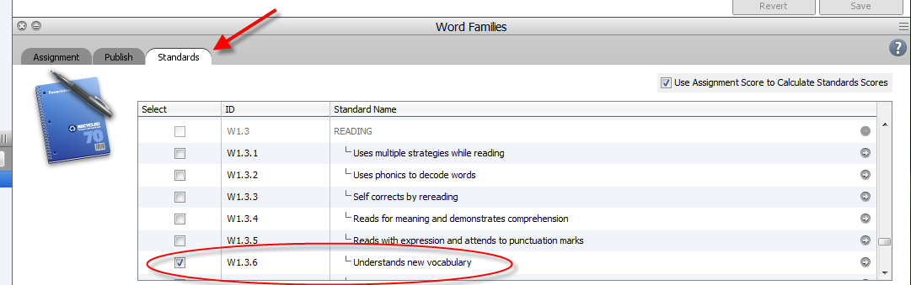

Standards should be checked in the Select box beside the appropriate standard. Next, click on Save to attach the standard to the assignment.

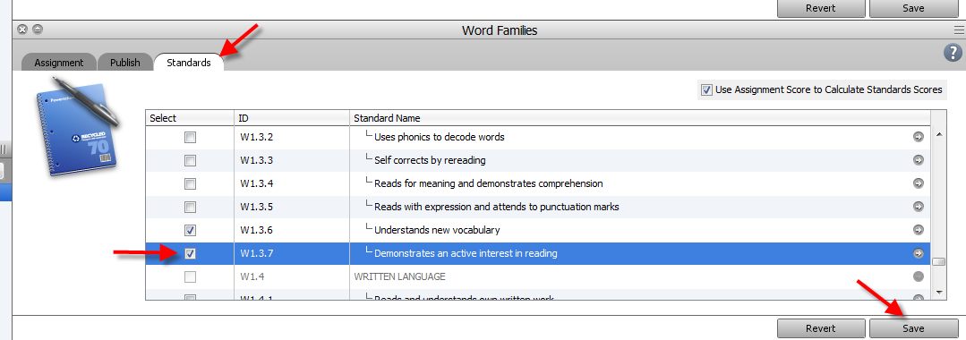

Standards grades should be aligned with the the assignment grade.

The PowerTeacher Administrator at your school can flag the Gradebook for teachers so that the standards’ scores will be calculated using the assignment grade. Teachers will see this indicated on the Standards tab by a checkmark in the box to Use Assignment Score to Calculate Standards Score.

***Place a checkmark in the Use Assignment Score to Calculate Standards Scores, when a single assignment is linked to a single standard.

***If a single assignment is linked to multiple standards, the Use Assignment Score to Calculate Standards Score box should be unchecked as the teacher has to manually enter standard scores for each standard.

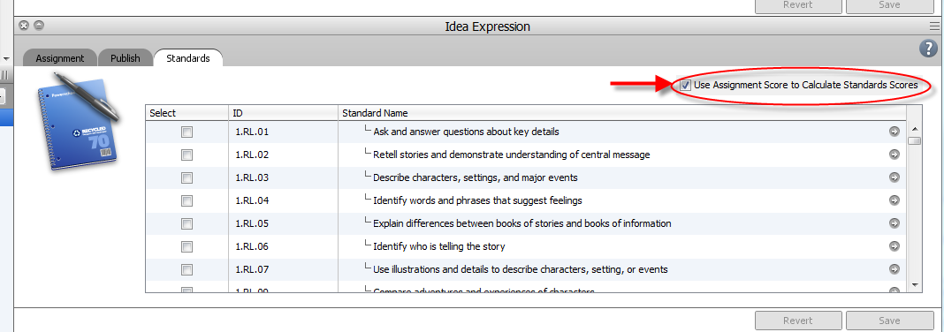

In order to see which standards have been selected and attached to an assignment, click on the S-> located beside the assignment on the Gradebook screen.

When the S-> has been clicked, the standards will be populated as a heading across the screen in the Gradebook.

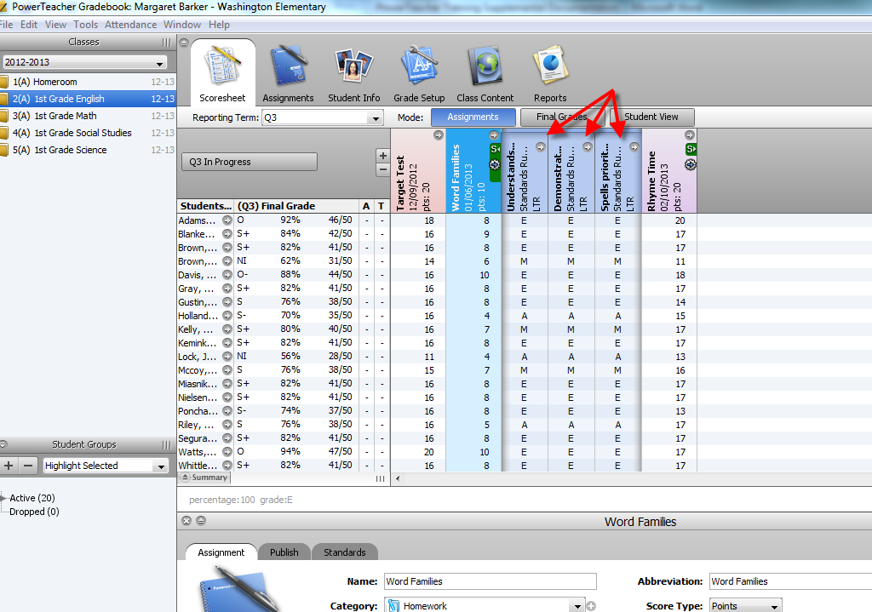
Work Habits should be assessed/graded in the teacher’s Homeroom class.

Select the Homeroom class from the Classes list. Click on the Assignments tab and then the + sign to add a new assignment. Proceed with the previously mentioned process for adding assignments, but there are no standards to link to these assignments.
Note: “Assignments” for work habits/conduct should be objective observations of the student, not written assessments.

