Step 1: Completing your self assessment:
- Log into Home Base/PowerTeacher from the Business Applications page on the intranet.

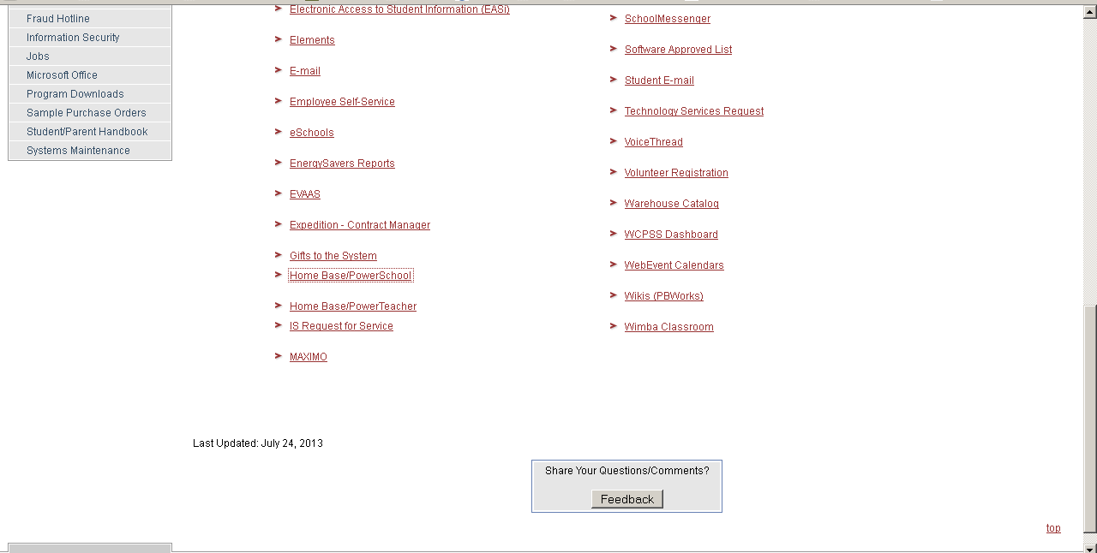

- Click on the PowerTeacher tab.
- At the Home Base login page, your username is wcpss followed by your 6-digit employee number, your password is your email password.
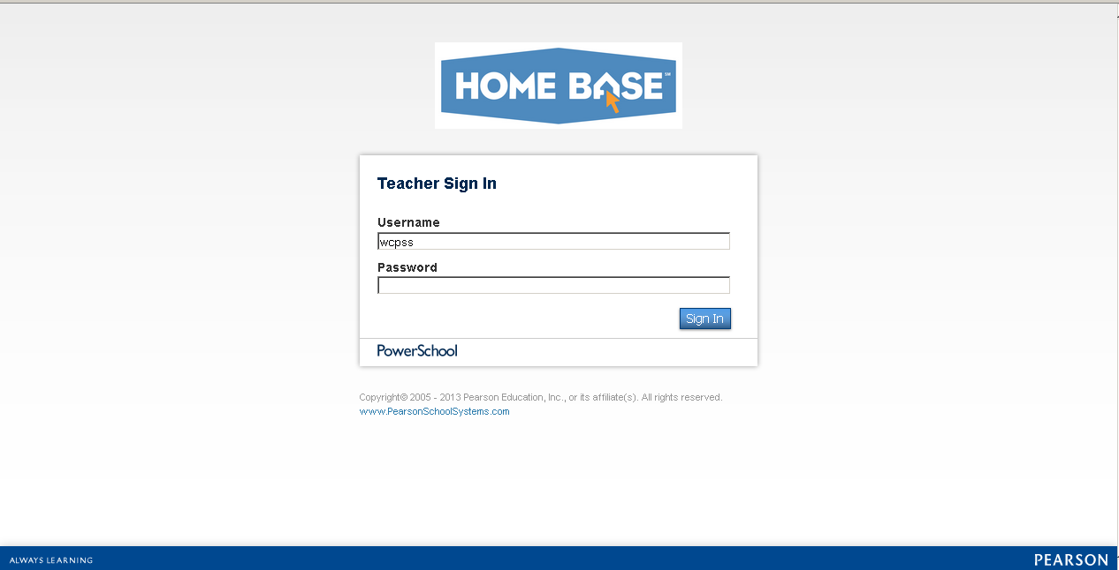

- Once you are in PowerTeacher, click on the arrow in the top right corner to take you to the available apps (see below).
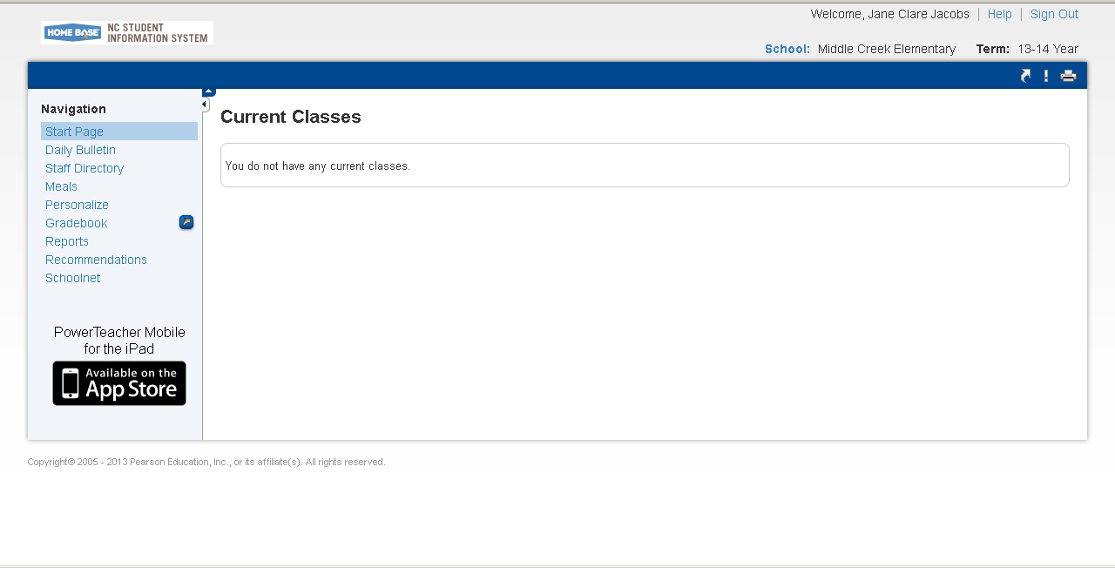
- When the app screen appears, click on North Carolina Educator Effectiveness System.
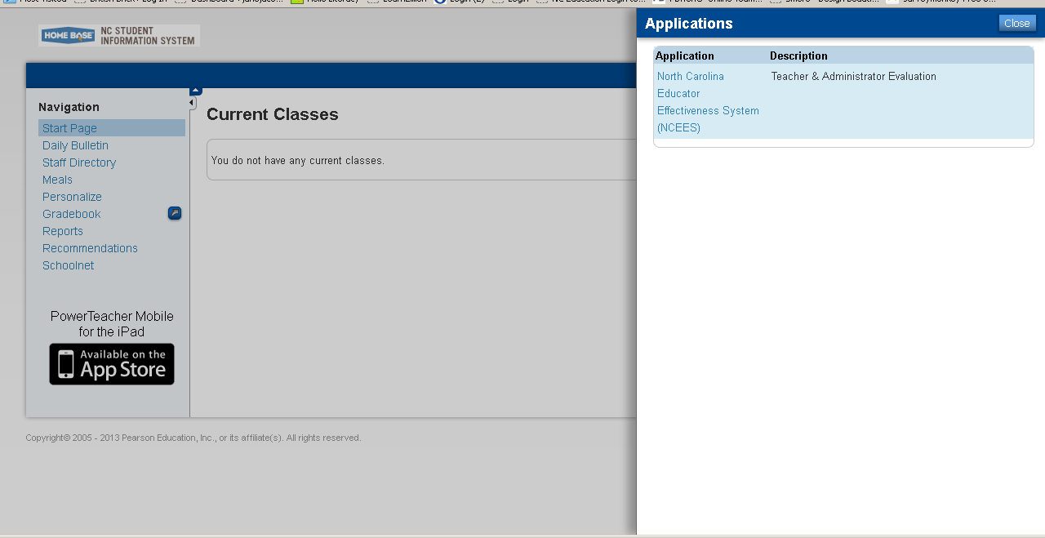

- If prompted, select Wake County from the drop down menu.
- You are now in the NCEES system.
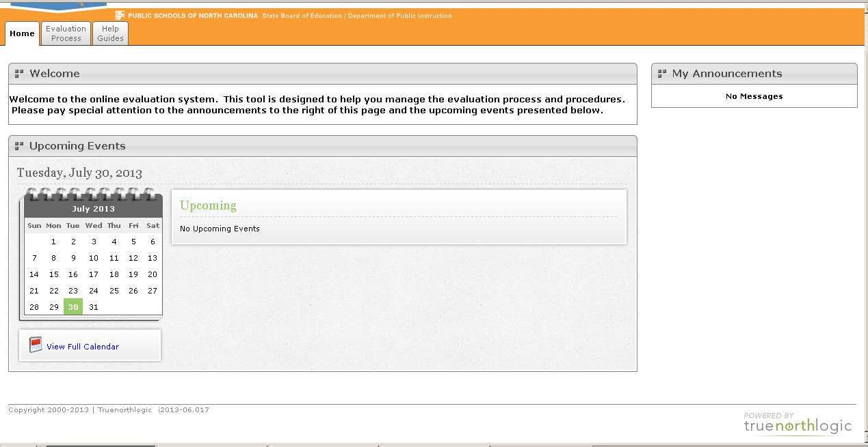

- There are 3 tabs at the top of your page. Click on the Evaluation Process tab to begin.
- You should see 2 sections – your teacher evaluation and your professional development plan. Click on the arrow to the left of the status of your teacher evaluation:
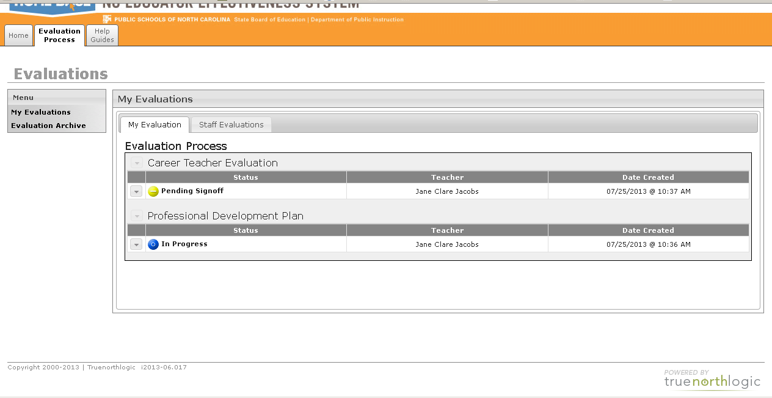
- Select edit from the drop down menu.
- By the training/orientation section, click the + sign by the word steps.
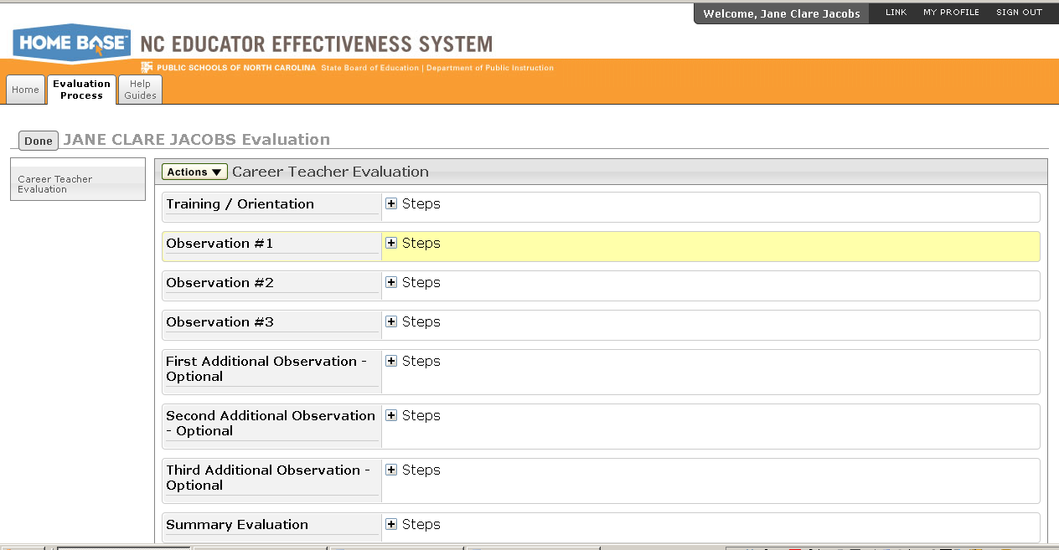
- Click on the Actions button and then click edit.
- Enter the date by clicking on the calendar icon. We received the information about the evaluation process on July 1st.
- Select save.
- Click Mark Complete from the actions button.
- The following message will appear: ‘The step Training/Orientation is now complete’. Click OK.
- From the same Actions tab, now click send. This is very important!!!!

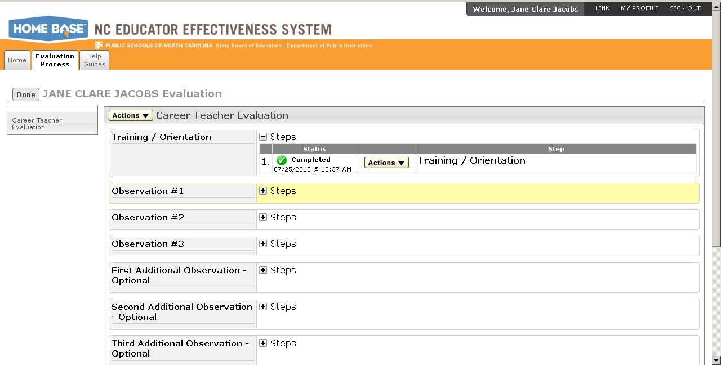
- The status will be changed to completed.
- Click Mark Complete.
- Now click Done on the left side of the screen by your name to take you back to the main screen.
- From the Professional Development Plan section, click on the arrow to the left of the status, and select start.
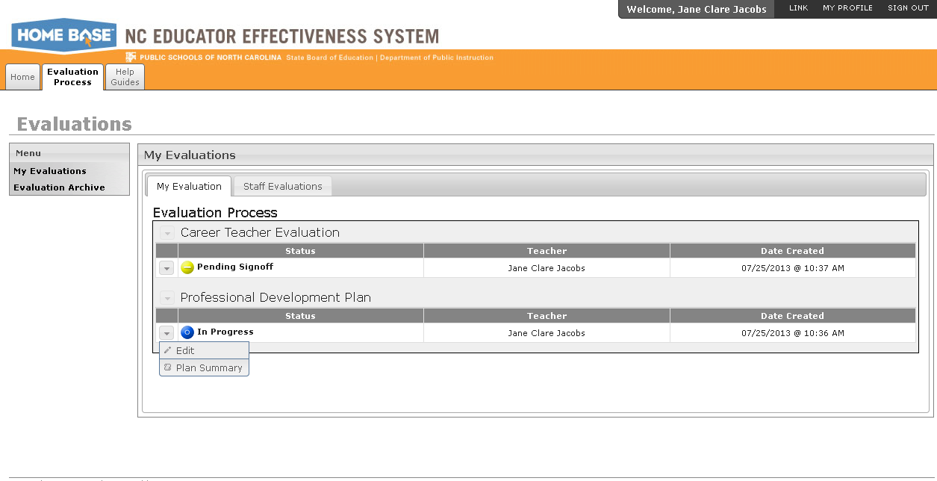

- By the PDP Initial Review section, click on the + sign by steps to see your options.
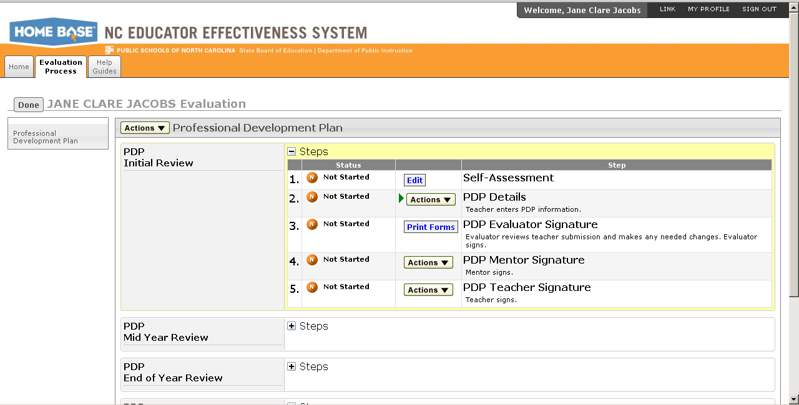
- By the self assessment, click edit.
- Complete the self assessment. When you are done, click save changes at the top left of the page.
- Click share so that your evaluator can see your self assessment (this is optional!)
- Click save and exit.
- You will be taken to the manage plan page. From here, click on the arrow below menu, and click finalize.
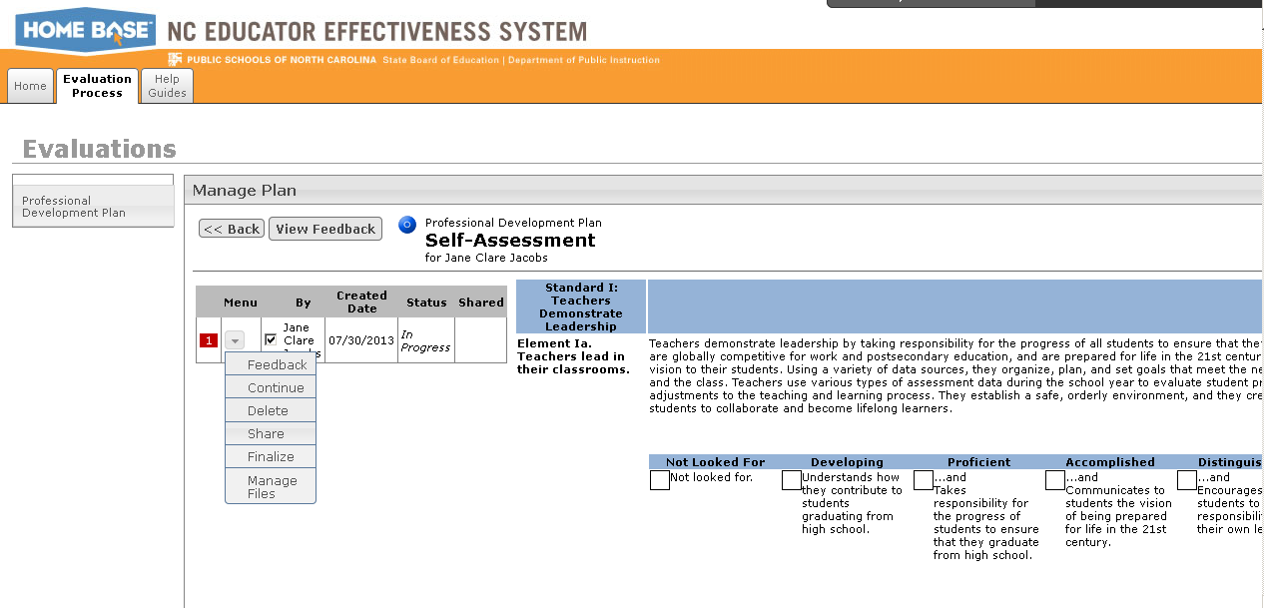
- When you have clicked finalize, mark complete will come up as an option. Click on mark complete.
- You will see a green arrow by PDP details, showing you that this is your next step!
Possible PDP goals:
- Discovery Education
- mClass
- PowerSchool Gradebook
- Mimio

